CHAPTER 6
IMPLEMENTATION PLANNING
6.1 Implementation Planning
- 3-tier architecture
'Three-tier' is a client-server architecture in which the user interface, functional process logic ("business rules"), data storage and data access are developed and maintained as independent modules, most often on separate platforms. The term "three-tier" or "three-layer", as well as the concept of multitier architectures, seems to have originated within rational Software.
The three-tier model is considered to be software architecture and a software design pattern. Apart from the usual advantages of modular software with well defined interfaces, the three-tier architecture is intended to allow any of the three tiers to be upgraded or replaced independently as requirements or technology change. For example, a change of operating system from Microsoft Windows to UNIX would only affect the user interface code.
Three nodes: client, application servers which process data for the clients and database servers which store data for the application servers. This configuration is called three-tier architecture.

The 3-Tier architecture has the following 3-tiers.
- Presentation Tier
- Logical Tier/Business Logic Tier/Application Tier
- Data Tier

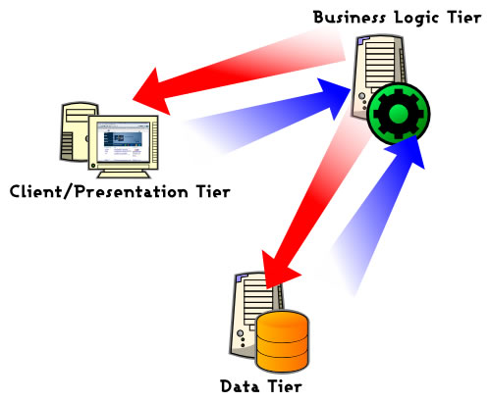

Fig. 6.3 3-Tier Architecture
6.1.1 Presentation Tier
The top-most level of the application is the user interface. The main function of the interface is to translate tasks and results to something the user can understand. This Tier is responsible for communication with the users and web service consumers and it will use objects from Business Layer to response GUI raised events.
6.1.2 Logical Tier/Business Logic Tier
The name Logical Tier is the combination of Business Tier and Data Access Tier. This layer coordinates the application, processes commands, makes logical decisions and evaluations, and performs calculations. It also moves and processes data between the two surrounding layers. The advantages of separating the Logical Tier into Business Tier and Data Access Tier are
- Increases code transparency
- Supports changes in Data Layer. You can change or alter database with out touching the Business Layer and this would be a very minimum touch up.

- Business Tier:
This sub tier contents classes to calculate aggregated values such like total revenue, cash flow and this tier doesn’t know about any GUI controls and how to access databases. The classes of Data Access Tier will supply the needy information from the databases to this sub tier.

- Data Access Tier:
This tier acts as an interface to Data Tier. This tier knows how to (from which database) retrieve and store information.

6.1.3 Data Tier:
Here information is retrieved from a jabber library. The information is stored only if needed in the log file. The information is then passed back to the logical tier for processing, and then eventually back to the user. We consider queries given by the chat user as a part of the Data Tier.
The following figure will explain you, how the request navigates to the layer. Here we are taking an example when client requests for the usage of different services.

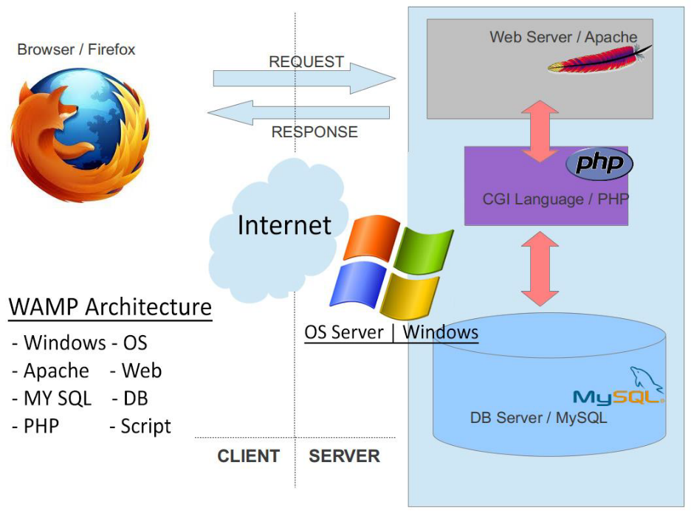

Fig. 6.2 Flow of 3-tier Architecture for Gmail Chatbot

As far as the physical deployment of the system is concerned the alternatives available to us are as follows:
- The system can be implemented as shown above where all three tiers are deployed far from each other. Here the presentation layer communicates with the business logic layer and the business logic layer communicates to Data tier. According to the client’s request it fetches data from the jabber library residing on Data tier applies appropriate business logic and provides resultant data back to client tier. Thus the business tier communicates with both the remaining tiers in the 3-tier architecture. But the presentation tier never communicates directly with the data tier. This provides security and reliable communication.
6.2 Modules(Services) Specification:
Following are the major features which are to be provided by the system:

Wikipedia: This feature will provide the information about any topic from Wikipedia.
Dictionary: This feature will give the meaning of particular word.
Bookmark: This feature will bookmark the specific URL which is mentioned.
Calculator: This feature will carry out simple mathematical calculations.
Weather: This feature will provide information about the weather at any place and near future.
Currency conversion: This feature will help the user for conversion/calculation of currency according to daily changes.
Unit conversion: This feature will help in conversion of unit.
Astrology: This feature will provide astrological information to the user.
Distance: This feature will give you the distance by road between any two cities or places.
Movie Showtime: This feature will provide the information about movie show times and theaters in which movies are currently shown.
Local Search: This feature will help the user for searching any kind of information like address and contact details of the hotels, parks, etc.
PNR Status: This feature allows user to check their PNR status.
Live cricket scores: This feature will help user to check the live score of cricket.
Chat with random: This feature is for fun and chat with random people.

6.3 Coding Standards
The Software needs to be updated from time to time according the changing needs of Users. So some standards are to be maintained in implementation and Coding, so that if the software needs to be modified due to some changes in User needs or some enhancements to be done, then its easy for the person to find some specific modules, pages, functions, variables or even the tables or stored procedures in the database.
This type of naming standards is called as “Naming Conventions”. It is very useful to reduce user errors and also ease the search process to find required information like variable, procedure, etc.

Variable Standards:
- I have placed the local variable declaration at the beginning of the script.
- For multiple declarations I have used new declaration on the next line.
- I have used meaningful variables name.

- Comment Standards:
The comment should describe what is happening, how it is being done, what parameters mean, which global are used and which are modified, and any registration or bugs.
The standards I have followed are:
- Every script should begin with a comment block, which describes the scripts purpose; any argument used (if applicable), and return values (if applicable), inputs-outputs, and name of script.
- Comment may also be used in the body of the script to explain individual sections or lines of codes.
- It is also used to describe variable definition or declarations.
- Inline comments should be made with the “//” comment style and should be indented at the same level as the code described.

- General Standards:
Spacing: I have typed a space before and after an Operator such a “+, *, >, <” etc.
Indentation: I have used tabs for the Indentation.
It is acceptable to break up the long statements such as long “if” condition on to multiple line or leave it in one long line.
The use of white space and simple comments is strongly encouraged.
Use case statements if a large number of “if” conditions arise instead of using the number of “if-else” statements.
All the variables, Constants and function declaration are at the top of the source code in the particular form or module.

6.3 Security Features;

The basic security feature is the user authentication. User must have to authenticate himself to use the system and its services and also for getting the system data. This we had done by providing each user unique username and password.
Another important thing is user authentication. Here the authenticated user may have a different access level or may have different role because here the entire user having the role based authentication, permission, and type of operation he wants to do. All users are assigned a particular level of authentication, according to which the system reacts to user action.
To have the login secured, all these passwords will be stored in an encrypted format.
Also the email for complete action item sent to the Assigner or ReportTo will contain a link so that the Assigner can directly click the link and enter into the system to change the Action Item Status. This link will contain the credentials for the Assigner to Login into the System which will be in the encrypted form so that he user credentials remain confidential.
The Encryption Method used in this is MD5 for key generation and this key generated through MD5 will be used to encrypt the data using TripleDES Encryption.

